Faculty of Computing
CS110: Fundamentals of Computer Programming
Class: 2k26 BSAI 3A
Lab 06: Repetition Structures - Iterative Problem Solving
CLO 1 | Understand the syntax and semantics of different programming constructs
CLO 3 | Build a program and associated documentation using appropriate IDE and supplementary tools

Time: 2:00 pm - 4:50 pm
Instructor: Sahar Arshad
Lab Engineer: Hassan Mohtashim

Introduction:
This lab develops practical skill with repetition structures in C++. Students will use for, while, do-while, nested loops, break, and switch in five applied scenarios. The tasks are intentionally different from routine classroom examples such as multiplication tables, factorials, basic star patterns, day-of-week menus, and number-guessing games. The emphasis is on choosing the correct loop, controlling termination, tracing changing values, and testing the program carefully.
Learning Objectives:
After completing this lab, you will be able to:
• Choose a for, while, or do-while loop according to whether repetition is count-controlled, condition-controlled, or must execute at least once.
• Identify and correctly implement loop initialization, test/termination condition, and update.
• Use nested loops and break to solve an iterative search problem.
• Combine do-while with switch to build a repeated command/menu interface.
• Process integer digits using %, /, loops, and switch without using arrays or strings.
• Compile, test, trace, and document iterative C++ programs in the IDE.
Tools/Software Requirement:
• The C++ IDE installed and configured in earlier labs (for example, Microsoft Visual Studio or the IDE specified by your instructor).
• A working C++ compiler integrated with the IDE.
• MS Word or equivalent for preparing the lab report.
Important: All five tasks are compulsory. Use only the C++ concepts studied so far. Do not use arrays, vectors, user-defined functions, or pre-built shortcuts unless a task explicitly allows them.
03-Hour Lab Plan:
Briefing and IDE check: 10 minutes | Tasks 1-5: 150 minutes | Report completion and submission check: 20 minutes.
Task 1 [CLO 1] - Fixed-Deposit Growth Tracker: for Loop (25 minutes):
A bank wants to show a customer how a fixed deposit grows at the end of each year. Instead of calculating only the final value, your program must show the year-by-year growth so that the repetition is visible.
1. Read double principalAmount, double annualRate, and int years from the user. Assume principalAmount > 0, annualRate > 0, and years > 0.
2. Store the running amount in a variable named currentBalance and initialize it with principalAmount.
3. Use a for loop that runs once for each year. During every iteration, update the balance using: currentBalance = currentBalance + currentBalance * (annualRate / 100.0).
4. After each update, display the year number and the balance at the end of that year. Do not use pow(); the purpose is to build compound growth through repetition.
5. After the loop ends, display totalInterest = currentBalance - principalAmount.
6. Required test: principalAmount = 100000, annualRate = 8, years = 5. Before running the program, trace the values produced after Year 1 and Year 2 by hand.
7. In your report, identify the initialization, condition, update, and repeated process of your for loop.
Deliverable: C++ code, the two-iteration hand trace, one output screenshot of the required test, and the short loop-component explanation.
Task 2 [CLO 1] - Drone Packet ID Mirror & Checksum: while Loop (30 minutes):
A small drone sends a numeric packet ID with every telemetry message. For quick verification, the ground station wants to reconstruct the ID in reverse order, count its digits, and calculate a simple digit checksum.
1. Read one positive integer packetID. Copy it into a temporary variable before processing so the original value is preserved.
2. Using one while loop, repeatedly extract the last digit with %, remove it with integer division /, and build reversedID.
3. In the same loop, calculate digitSum and digitCount.
4. After the loop, display the original ID, reversed ID, number of digits, and checksum (digitSum).
5. Use an if-else statement to print "Mirror packet ID" when packetID == reversedID; otherwise print "Normal packet ID".
6. Required tests: packetID = 73042 and packetID = 1221. Predict which test will be identified as a mirror packet before running.
7. In 2-3 sentences, explain why a temporary copy is needed and what condition finally terminates the while loop.
Deliverable: C++ code, screenshots of both tests, your prediction, and the short explanation.
Task 3 [CLO 3] - Prime Communication Channel Scanner: Nested for Loops + break (35 minutes):
A communication system reserves prime-numbered channel IDs for a special transmission mode. Build a scanner that finds all prime channel numbers up to a user-supplied limit and reports their total.
1. Read an integer limit in the range 2 to 100.
2. Use an outer for loop to examine every candidate number from 2 up to limit.
3. For each candidate, set a Boolean variable such as isPrime = true, then use an inner for loop to test possible divisors starting from 2.
4. If a divisor is found, set isPrime to false and use break to leave the inner loop immediately. The outer loop must continue with the next candidate.
5. Whenever isPrime remains true, print the candidate, add it to primeSum, and increment primeCount.
6. At the end, display the list of prime channels, primeCount, and primeSum.
7. Required tests: limit = 10 and limit = 30. Before compiling, list the prime values you expect for limit = 10.
8. In your report, explain the role of the outer loop, inner loop, and break statement. State why break does not end the entire program.
Deliverable: C++ code, expected prime list for limit = 10, screenshots of both runs, and the nested-loop/break explanation.
Task 4 [CLO 1] - Smart Locker Kiosk: do-while + switch (30 minutes):
A campus smart locker can hold only one parcel at a time. The kiosk must show its command menu at least once and continue operating until the user chooses to exit.
Use the following menu:
Choice | Action
1 | Store a parcel
2 | Collect the parcel
3 | Check locker status
0 | Exit kiosk
1. Declare bool occupied = false and int choice.
2. Use a do-while loop to display the menu, read choice, and process the command. The loop must continue until choice == 0.
3. Use switch(choice). In case 1, store a parcel only when the locker is empty; otherwise print "Locker already occupied".
4. In case 2, allow collection only when occupied is true; otherwise print "Locker is empty". Update occupied when a parcel is stored or collected.
5. In case 3, display the current locker status. Handle any other non-zero choice with default.
6. Put break after each case so one command does not fall through into another.
7. Required command sequence: 3, 1, 1, 3, 2, 3, 0. Before running, write the status/messages you expect after each command.
8. In your report, expladin why do-while is more natural than while for this kiosk and what would happen if a break were removed from a switch case.
Deliverable: C++ code, predicted message sequence, one screenshot showing the complete required sequence, and the do-while/switch explanation.
Task 5 [CLO 3] - Emergency Code Verbalizer: Loop + switch (30 minutes):
An emergency console receives a numeric code but operators must read it aloud digit by digit. Write a program that prints every digit in words while preserving the original left-to-right order.
1. Read one positive integer code. Keep a copy named originalCode.
2. Determine the highest decimal place using a loop. One approach is to begin with divisor = 1 and repeatedly multiply divisor by 10 while the number still has another digit to its left.
3. Use a loop that moves divisor from the highest place down to 1. At each position, extract the current digit using integer division and %. Do not convert the number to a string.
4. Use switch(digit) to print Zero, One, Two, ... Nine. Put a space between words.
5. Required tests: 50704 and 8301. Your program must print zeros that occur inside the code; for example, the zero in 50704 must not disappear.
6. Add a counter that reports how many digits were spoken.
7. In 2-3 sentences, explain why processing from the highest place value preserves the original order and why switch is suitable for digit-to-word conversion.
Deliverable: C++ code, screenshots of both required tests, the reported digit count, and the short explanation.
Deliverables:
Compile a single Word document and submit it on LMS. Organize the report under Task 1 through Task 5. All five tasks are compulsory. For each task, include the requested C++ code, output/IDE screenshot(s), required prediction or hand trace, and the short explanation/observation. The submitted code must be the code demonstrated during the lab.
Lab Rubrics
Your Lab 6 will be graded according to the following rubrics.
Lab Rubrics for Lab 6
Sr. No. | Assessment | Unacceptable (0 Marks) | Does Not Meet Expectations (1/2 Marks) | Meets Expectations (3/4 Marks) | Exceeds Expectations (5 Marks)
1 | Repetition structures and iterative problem solving (CLO1, PLO1) | The student did not submit the required work, submitted work that cannot be evaluated, or used unfair means/plagiarized work. | The student is unable to select or construct appropriate for, while, or do-while loops. Initialization, loop condition, update, nested-loop logic, or termination is incorrect and programs require substantial help. | The student demonstrates partial understanding of repetition structures. Most tasks run with limited guidance, although some loop-control, digit-processing, nested-loop, break, or switch errors remain. | The student correctly selects and applies the required repetition structures; controls initialization, testing, updates, and termination; uses nested loops, break, and switch appropriately; and accurately explains program behavior.
2 | IDE usage, testing, program construction, and documentation (CLO3, PLO5) | The student did not submit the required work, submitted work that cannot be evaluated, or used unfair means/plagiarized work. | The student has difficulty creating, building, and running the programs in the IDE and provides incomplete test evidence, traces, screenshots, comments, or documentation. | The student can build and run the required programs and complete the specified tests with limited help. Code, screenshots, traces/predictions, and explanations are mostly complete and organized. | The student independently builds, runs, tests, and documents all five programs; uses clear identifiers and comments; provides complete screenshots and required working; and presents a well-structured report.

Task 1
Year 1 (i = 1) interest: 100000 * (8 / 100.0) = 8000
balance: currentBalance = currentBalance + 8000 -> 108000
year Number: 1 current Balance: 108000
Year 2 (i = 2) interest: 108000 * 0.08 = 8640
balance: currentBalance = currentBalance + 8640 -> 116640
year Number: 2 current Balance: 116640

initialization: Start i at 1 for year 1.
Condition: Keep going as long as i is less than or equal to total years.
Update: Add 1 to i after every loop.
Repeated Process: Calculate interest, add it to balance print new total.

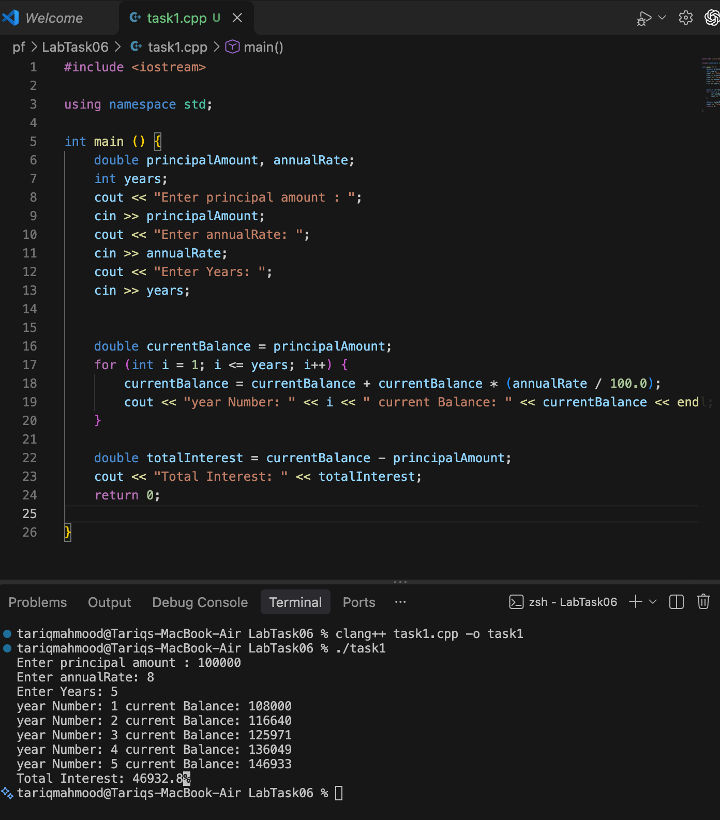

Task 2
1221 should be mirrored since its the same number when reversed
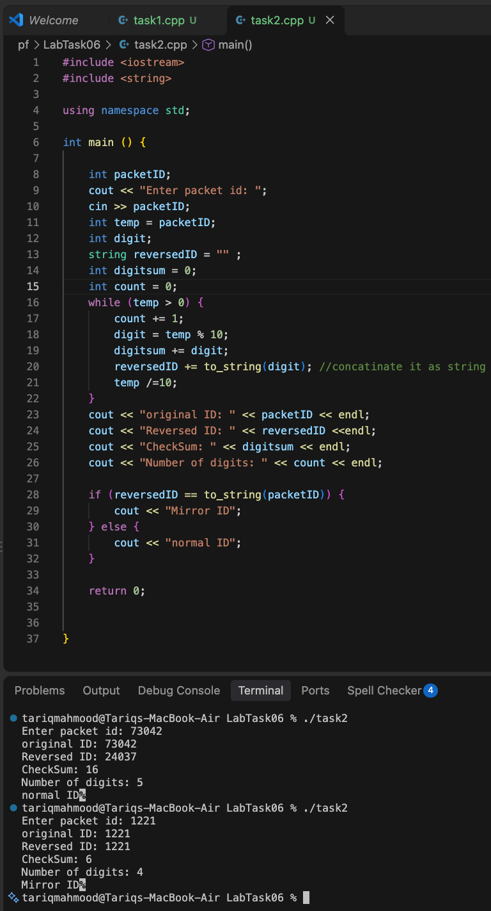
A temporary copy is needed since modifying the original within the loop means that we won’t be able to check if the ID is mirrored or not since the original value of check would be modified.

Task 3
For limit = 10 i expect:
2 3 5 7

Break 0only exits the inner for loop and move to the next iteration of the outer for loop

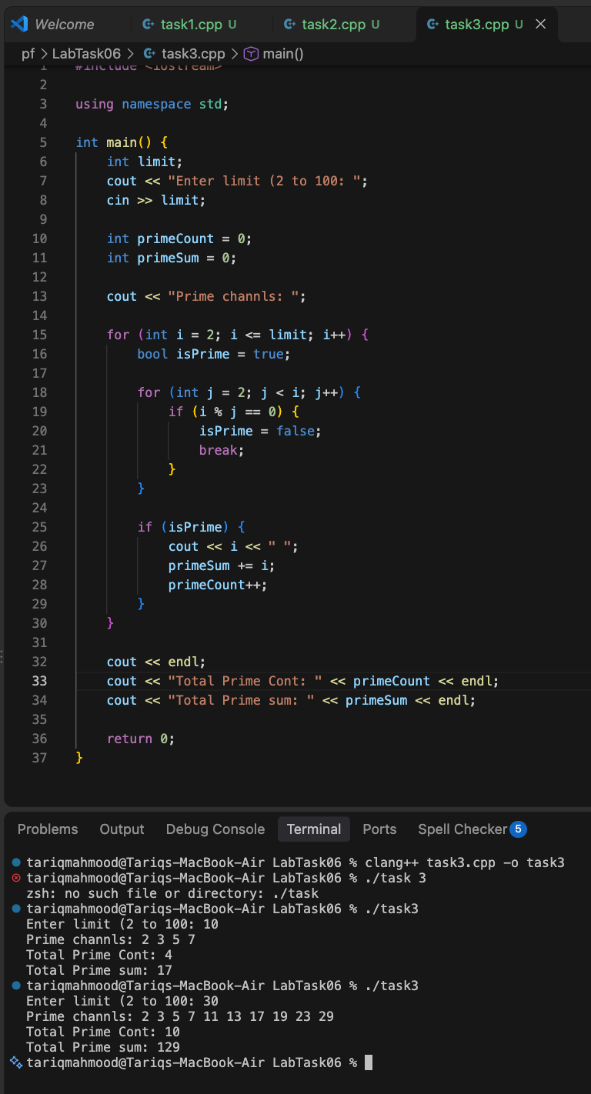

Task 4
A do while loop is used since we need to keep Doing 1 task repetitively UNTIL the user enters 0 , so its task first condition later making it perfect for displaying menus . Removing a break from a switch case would lead the choice input to fall through to the next case even if the current case passes.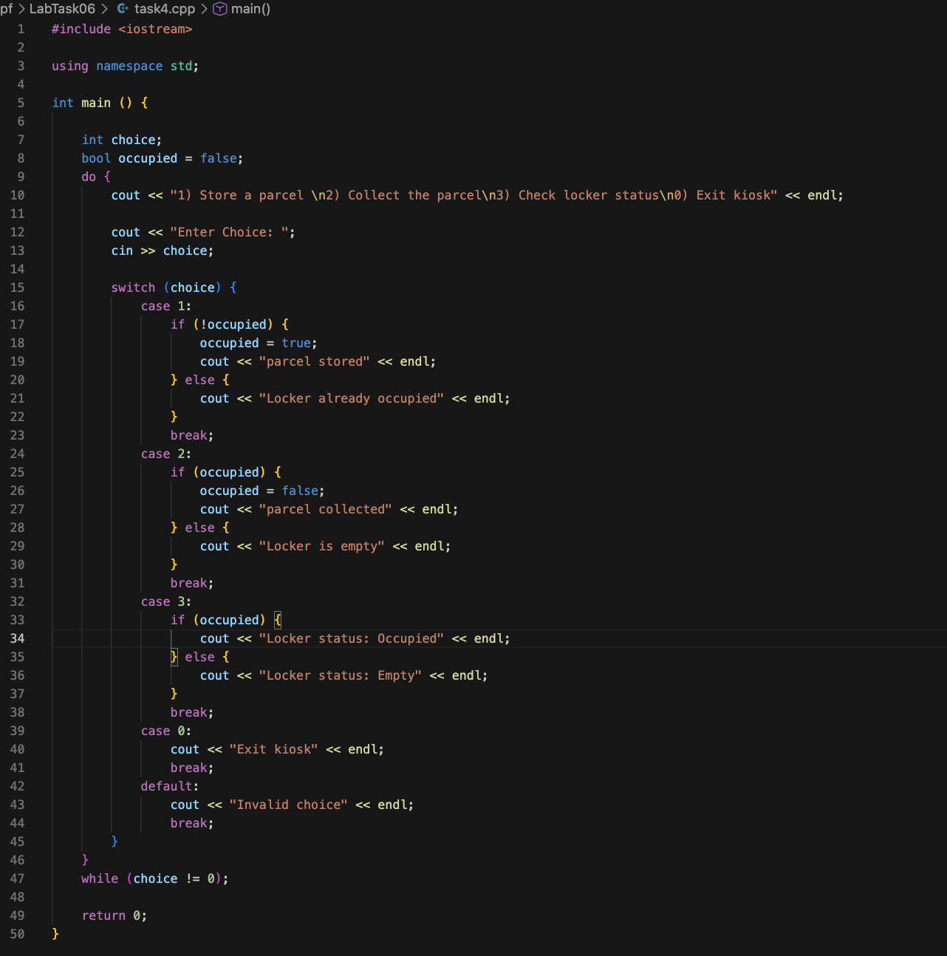

expected outputs for sequence (3, 1, 1, 3, 2, 3, 0):
- 3: Locker status: Empty
- 1: parcel stored
- 1: Locker already occupied
- 3: Locker status: Occupied
- 2: parcel collected
- 3: Locker status: Empty
- 0: Exit kiosk
Actual:

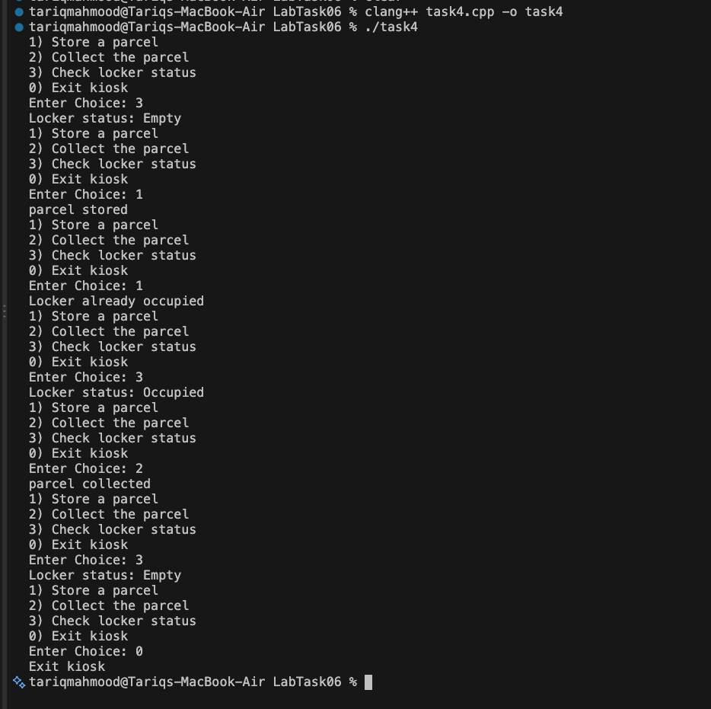

Task 5

processing from the highest place value preserves the original order because we find the largest divisor first, meaning we extract and print the leftmost digit first before moving down through the lower place values using division and modulo instead of going backwards. we use a switch statement because it is just much easier since we can match each digit directly to its word without making a huge mess of if else chains everywere.
Code:
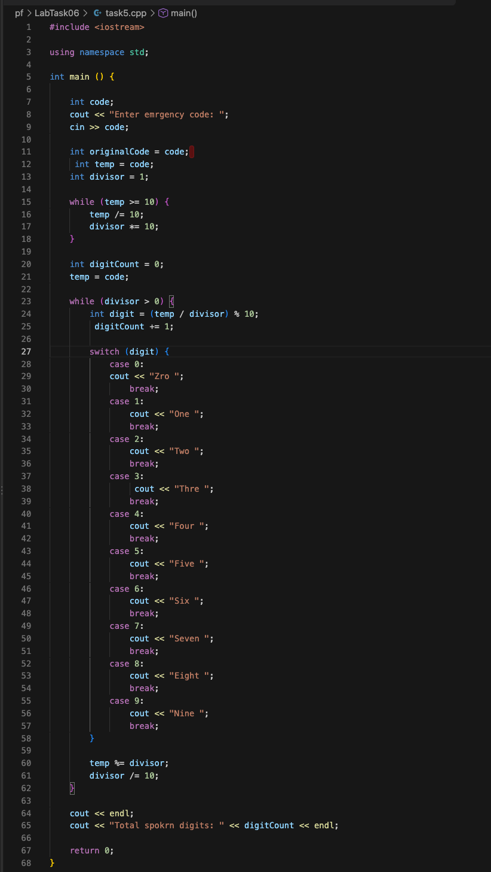

OUTPUT:
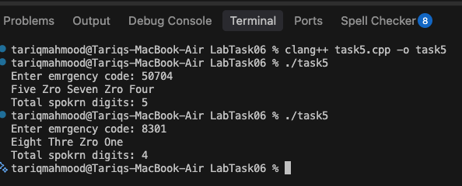

Github repo for all source code and files:: https://github.com/ARTariqDev/Nust-AI-2k26/tree/main/pf/LabTask06

